Small Stellated Dodecahedron

Definition
# Source: AI Source: Provided by: [Data Path: Persons Table -> ID Column: 1, Name_En Column: Motasem Essam] -> From: [ChatGPT] on [7/25/2026]
The Small Stellated Dodecahedron is a regular non-convex polyhedron belonging to the four classical Kepler–Poinsot Polyhedra. It is formed by extending the pentagonal faces of a regular dodecahedron until the extended edges intersect to create star-shaped faces.
It consists of 12 regular pentagrammic faces, with five pentagrams meeting at each vertex.
Its Schläfli symbol is:
$$\boxed{\{\frac{5}{2},5\}}$$
Where:
- $5/2$ represents the regular pentagram face.
- $5$ indicates that five faces meet at each vertex.
It is called small stellated because its stellation points are shorter than those of the Great Stellated Dodecahedron.

Geometric Representation
# Source: AI Source: Provided by: [Data Path: Persons Table -> ID Column: 1, Name_En Column: Motasem Essam] -> From: [ChatGPT] on [7/25/2026]
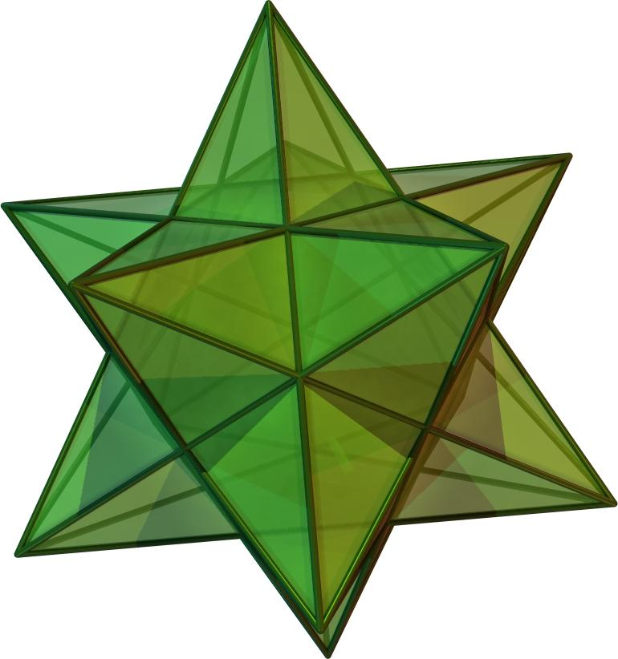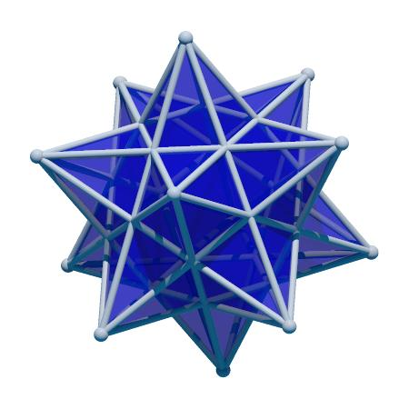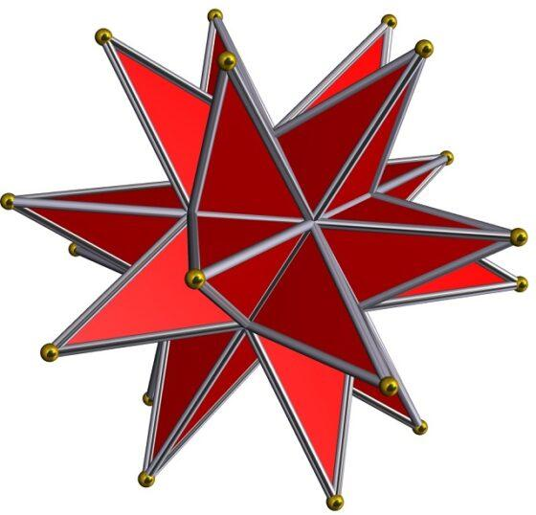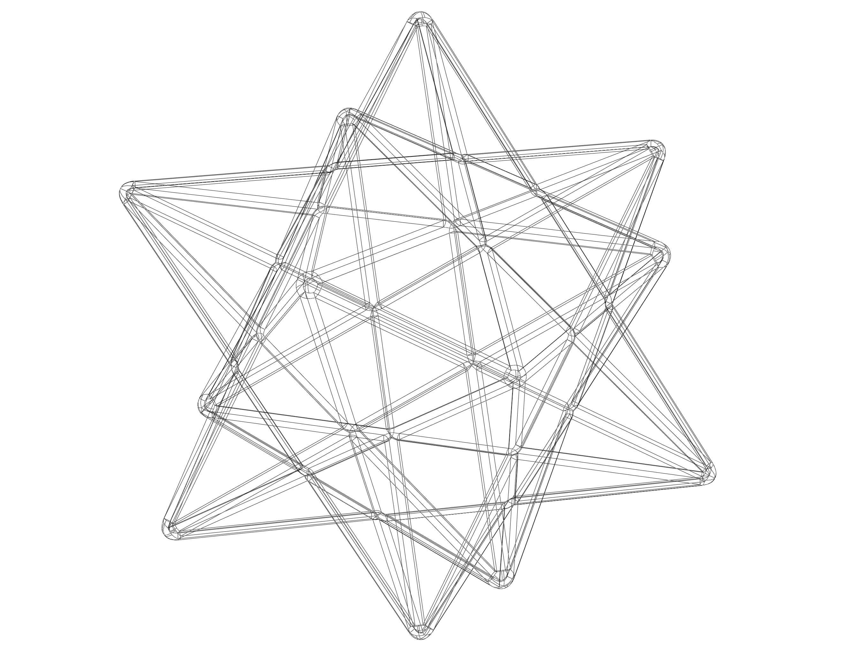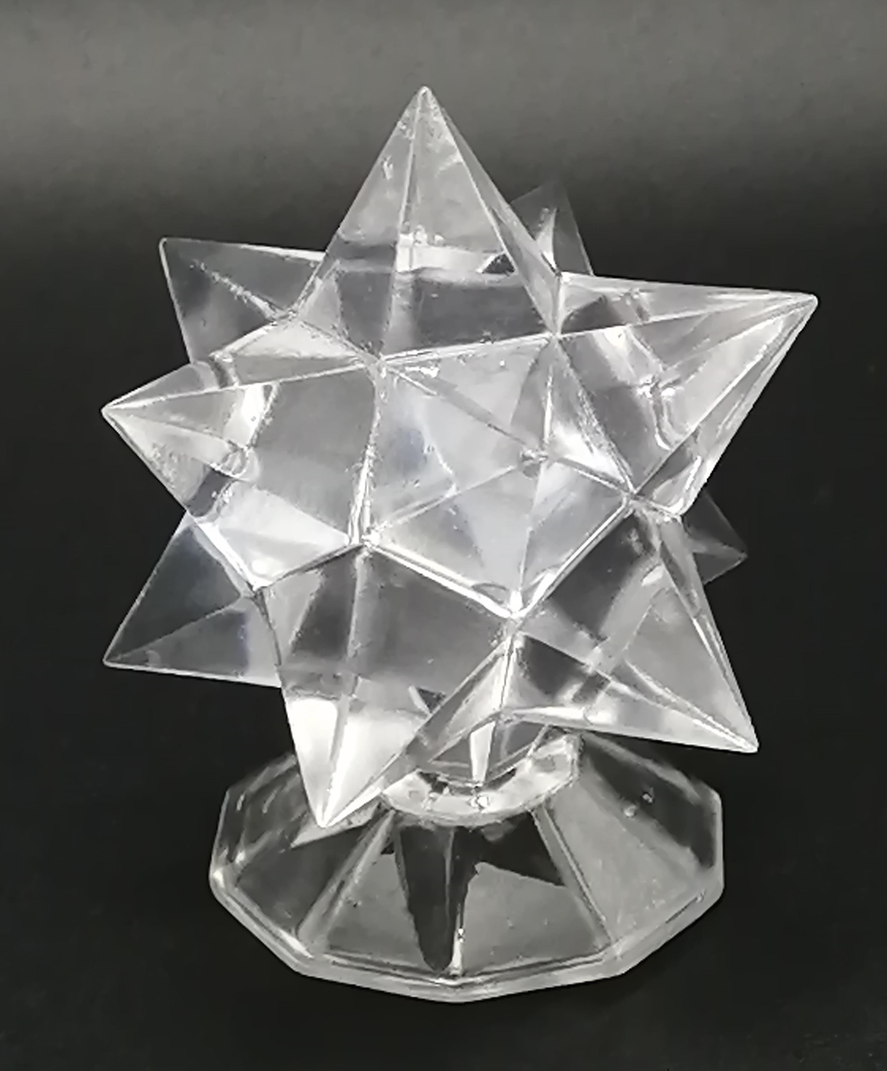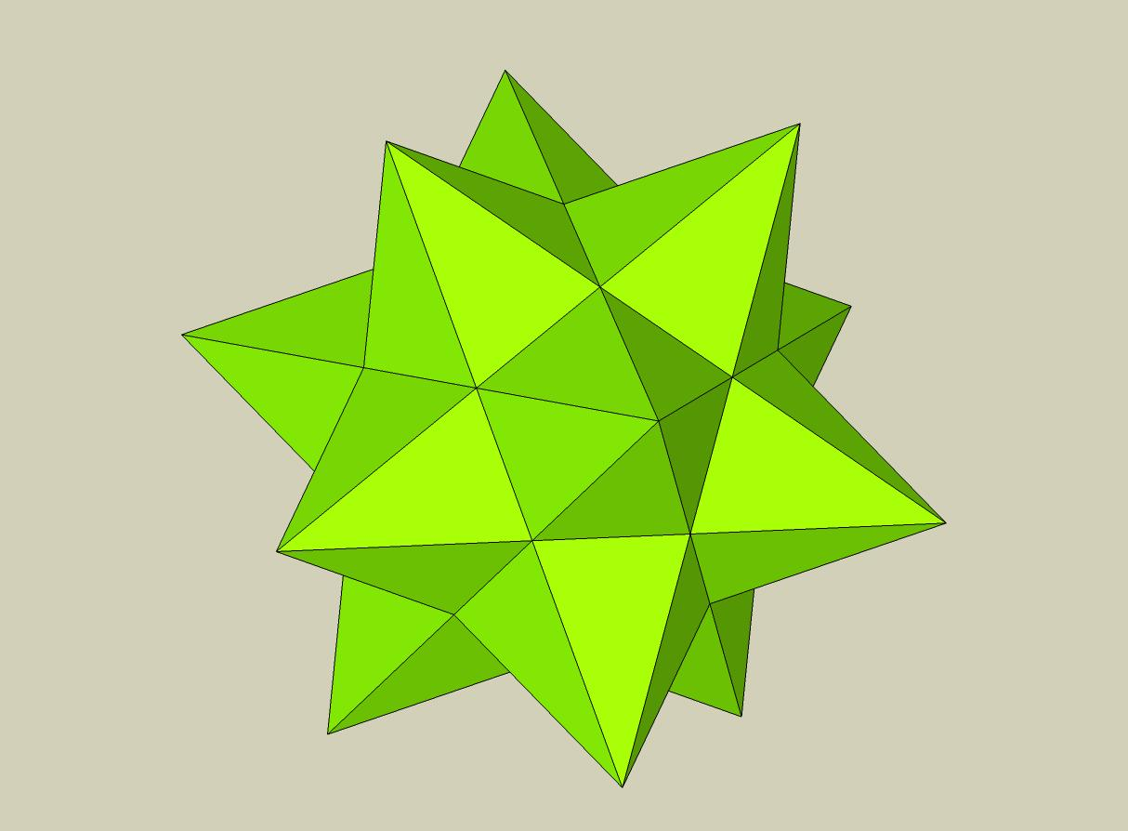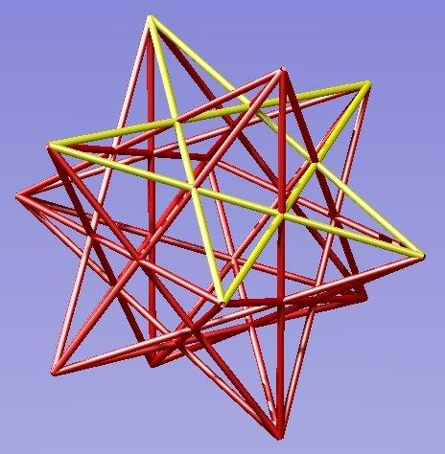

Geometric Structure
# Source: AI Source: Provided by: [Data Path: Persons Table -> ID Column: 1, Name_En Column: Motasem Essam] -> From: [ChatGPT] on [7/25/2026]
The Small Stellated Dodecahedron has a star-like structure created by 12 pentagrammic faces extending outward from its central region.
Its structure includes:
- Pentagrammic Faces: Twelve regular five-pointed star polygons.
- Edges: Thirty edges forming the boundaries of the pentagrammic faces.
- Vertices: Twelve outer vertices where five pentagrammic faces meet.
- Stellated Points: Sharp outward-pointing tips formed by the extended pentagonal geometry.
- Intersecting Regions: Its faces intersect in space, producing a non-convex self-intersecting structure.

Mathematical Properties
# Source: AI Source: Provided by: [Data Path: Persons Table -> ID Column: 1, Name_En Column: Motasem Essam] -> From: [ChatGPT] on [7/25/2026]
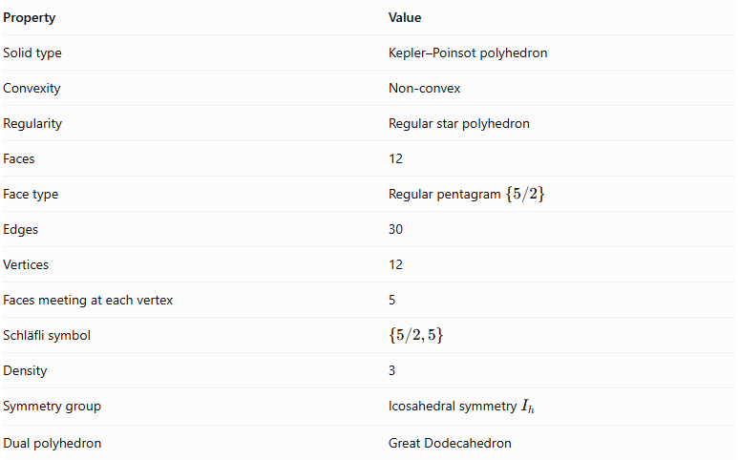
Property | Value
Solid type | Kepler–Poinsot polyhedron
Convexity | Non-convex
Regularity | Regular star polyhedron
Faces | 12
Face type | Regular pentagram $\{5/2\}$
Edges | 30
Vertices | 12
Faces meeting at each vertex | 5
Schläfli symbol | $$\{5/2,5\}$$
Density | 3
Symmetry group | Icosahedral symmetry $I_{h}$
Dual polyhedron | Great Dodecahedron

Face Composition
# Source: AI Source: Provided by: [Data Path: Persons Table -> ID Column: 1, Name_En Column: Motasem Essam] -> From: [ChatGPT] on [7/25/2026]
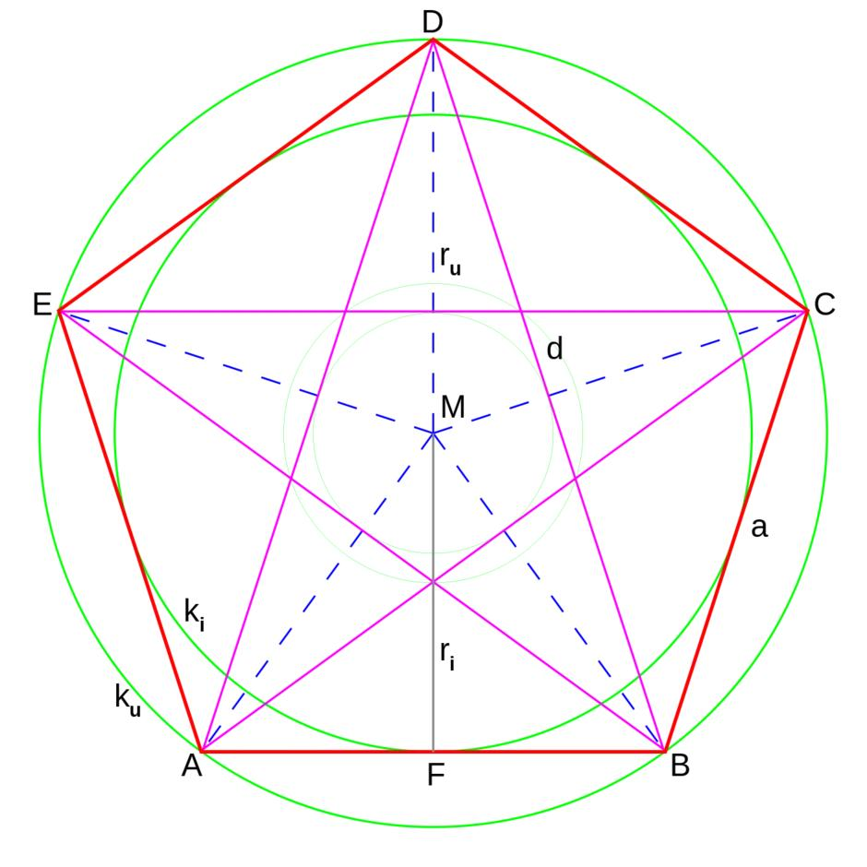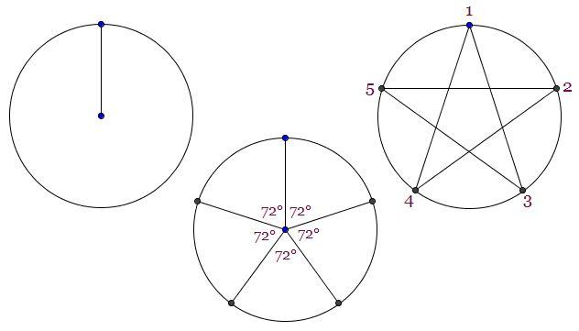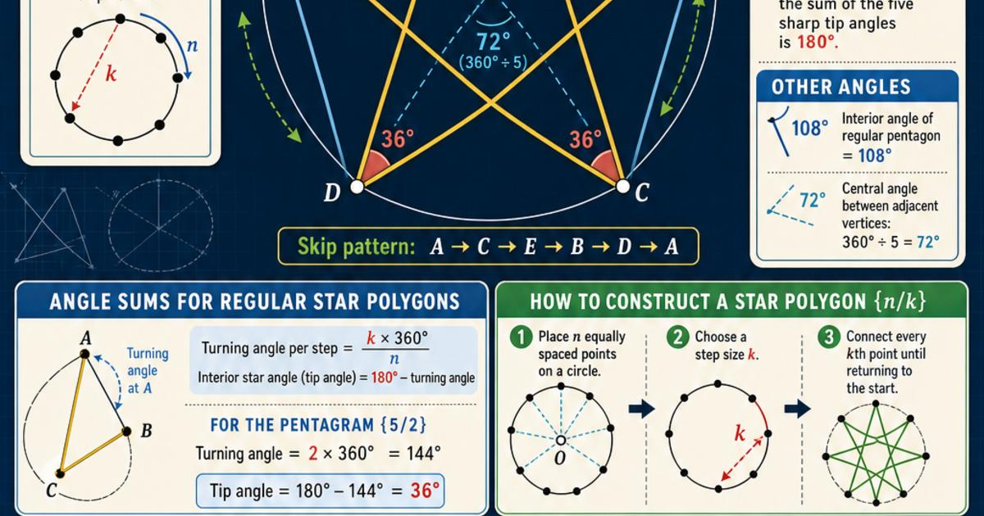
The Small Stellated Dodecahedron is composed entirely of regular pentagrams.
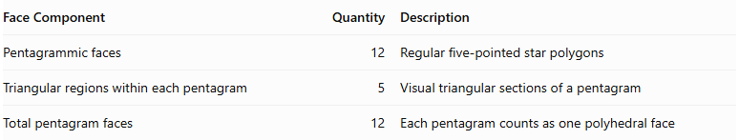
Face Component | Quantity | Description
Pentagrammic faces | 12 | Regular five-pointed star polygons
Triangular regions within each pentagram | 5 | Visual triangular sections of a pentagram
Total pentagram faces | 12 | Each pentagram counts as one polyhedral face
Important: Each pentagram is counted as one star-polygon face, not as five independent triangular faces, when using the standard Kepler–Poinsot face-counting convention.

Vertex Configuration
# Source: AI Source: Provided by: [Data Path: Persons Table -> ID Column: 1, Name_En Column: Motasem Essam] -> From: [ChatGPT] on [7/25/2026]
Five pentagrammic faces meet at every vertex.
The vertex configuration is represented by:
$$(\frac{5}{2})^{5}$$
This indicates that five pentagrammic faces surround each vertex.
The solid shares the same set of vertex positions as a regular icosahedron, although its faces connect those vertices differently.

Construction
# Source: AI Source: Provided by: [Data Path: Persons Table -> ID Column: 1, Name_En Column: Motasem Essam] -> From: [ChatGPT] on [7/25/2026]
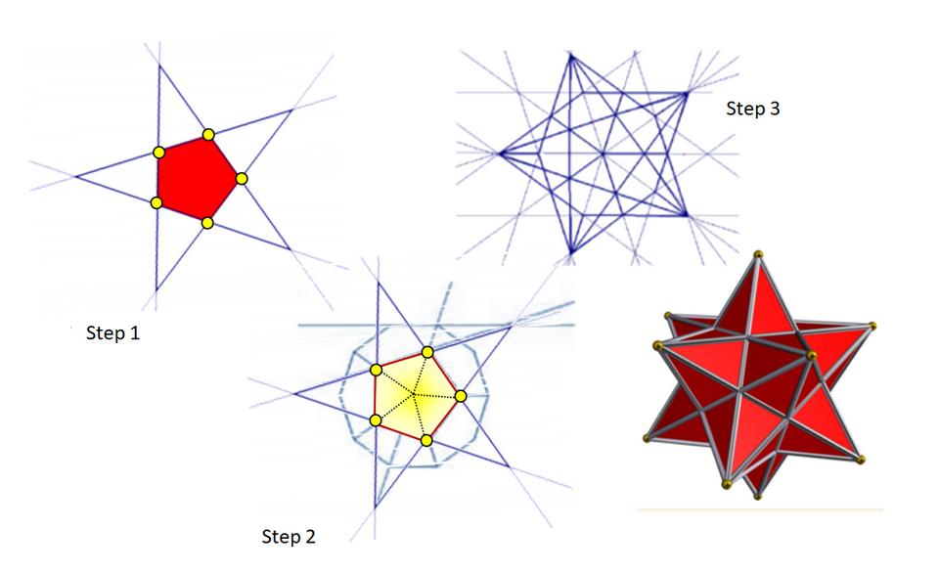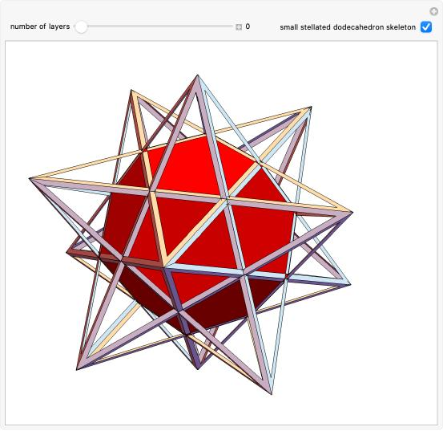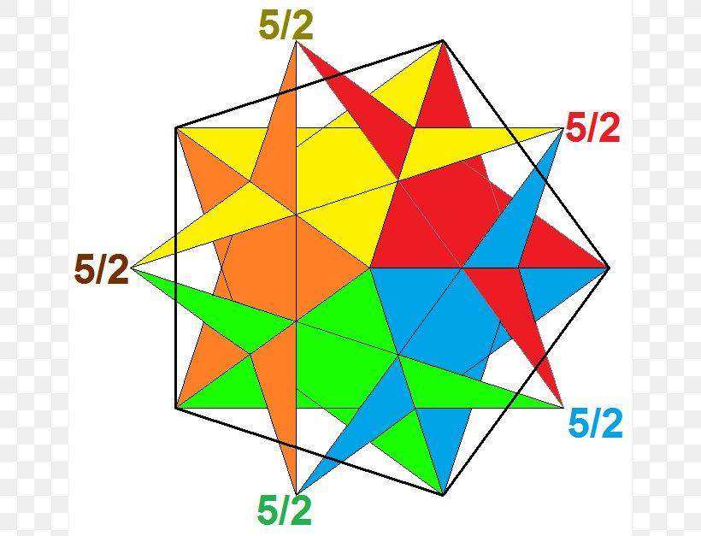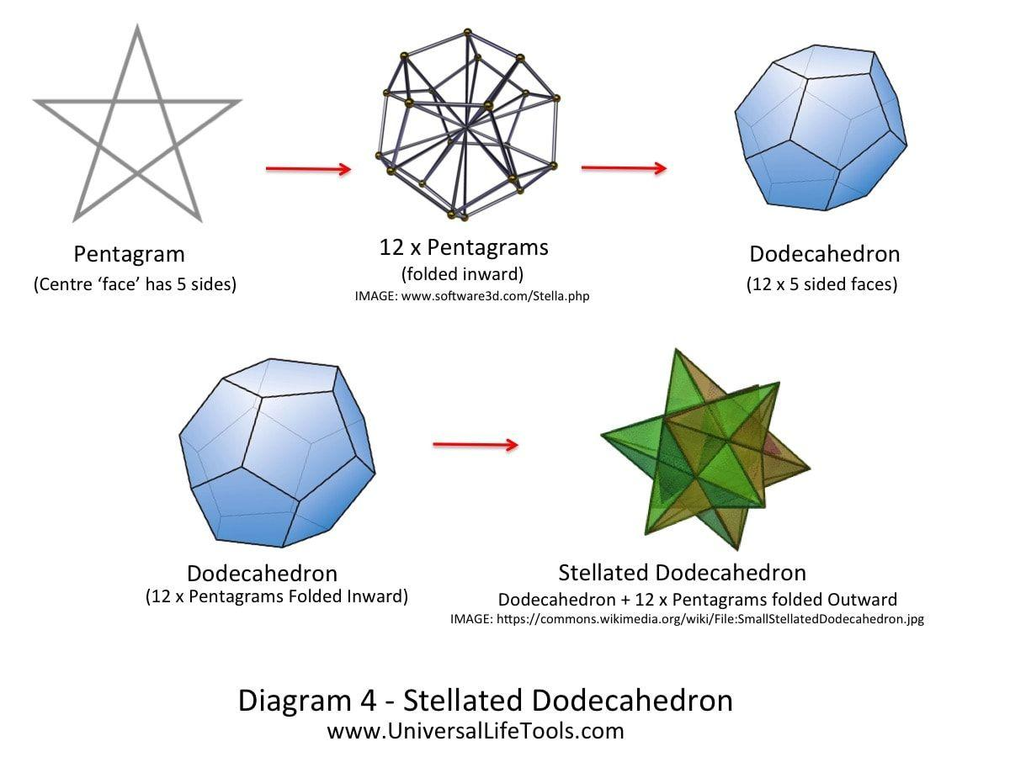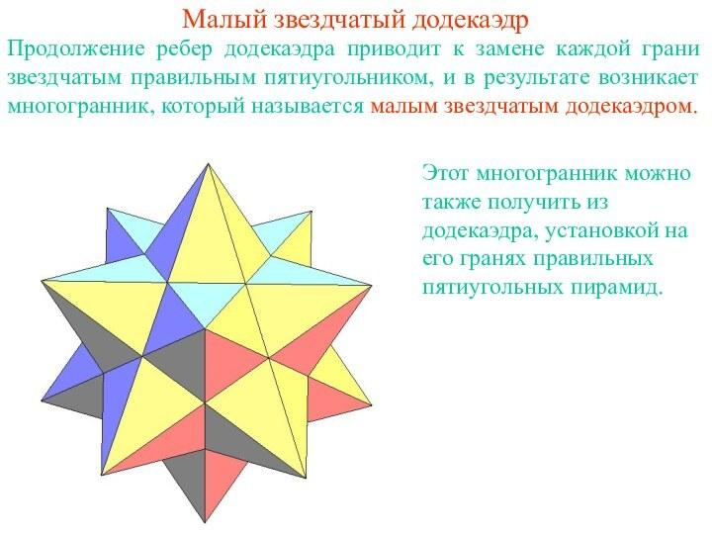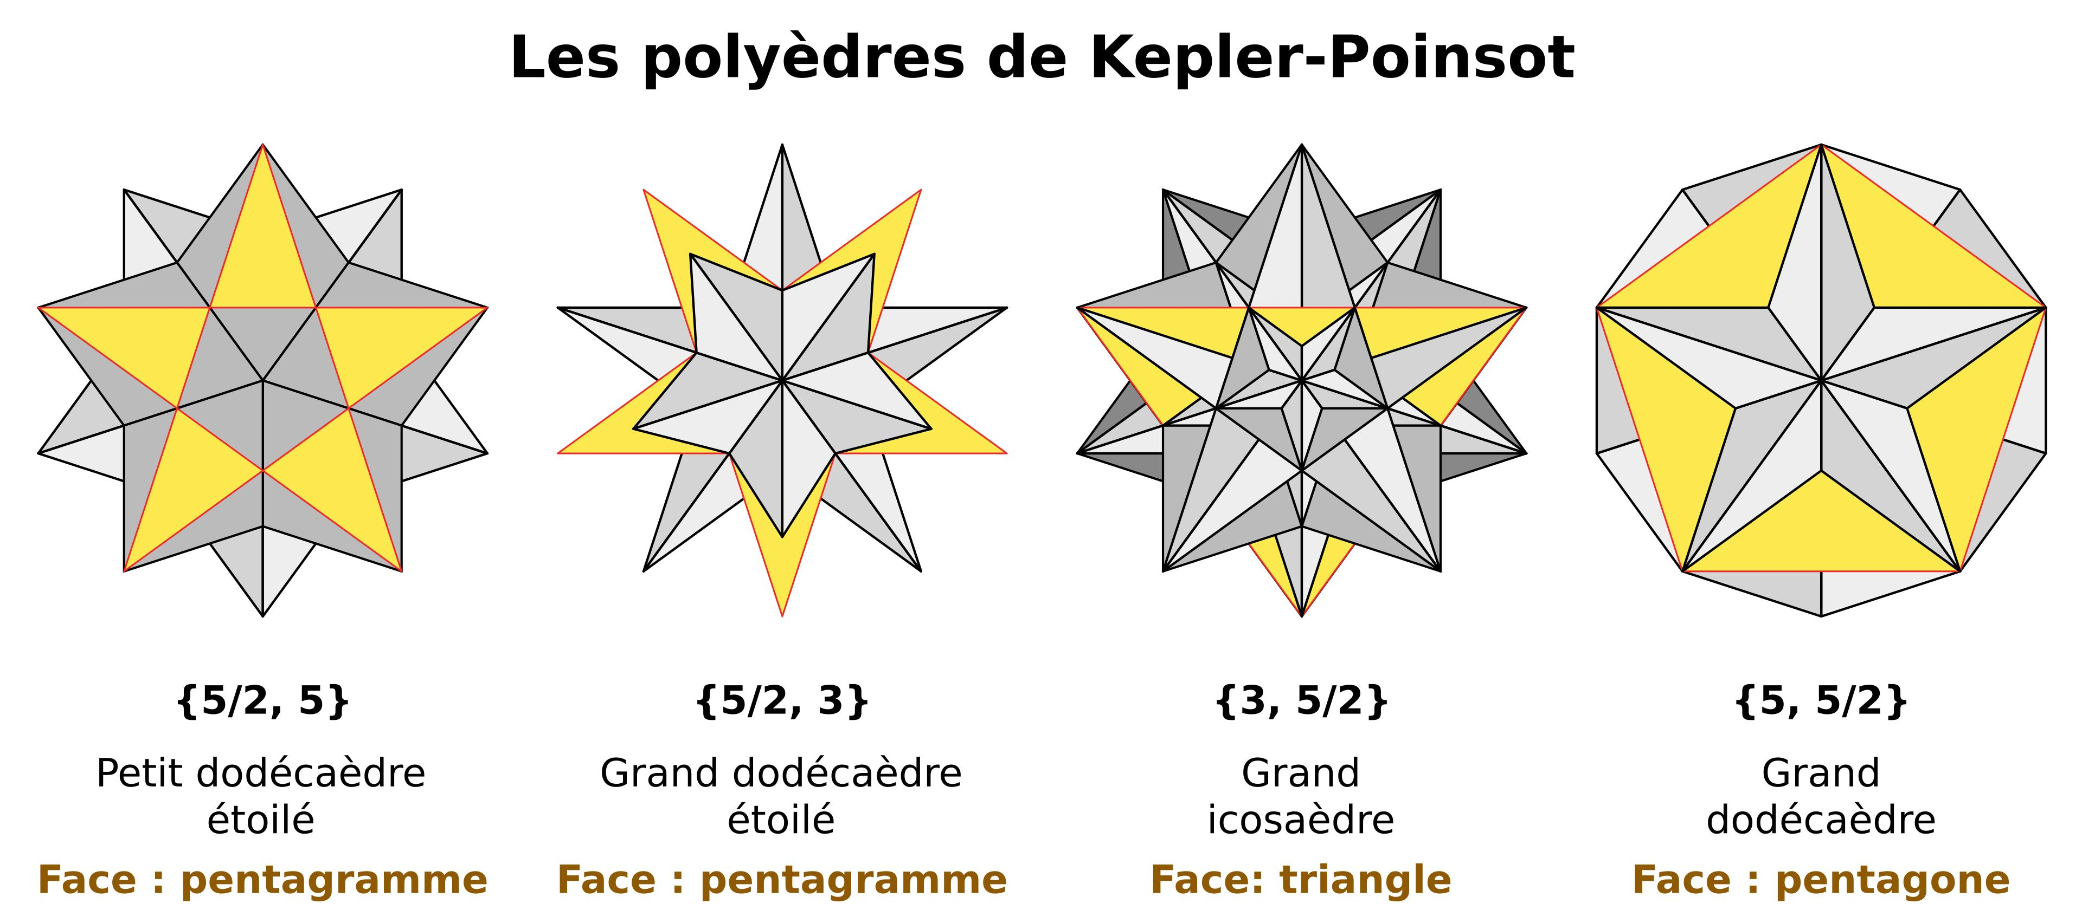
The Small Stellated Dodecahedron can be constructed through the stellation of a regular dodecahedron.
Construction steps:
- Begin with a regular dodecahedron containing 12 regular pentagonal faces.
- Extend the edges of its pentagonal faces beyond their original boundaries.
- Continue the extensions until they intersect to form pentagrammic faces.
- Extend the resulting star-shaped geometry outward to create the complete stellated solid.
- Ensure that the 12 pentagrammic faces form the regular symmetrical arrangement.
Another construction method is to build a pentagonal pyramid on each face of a dodecahedron, with the pyramid heights chosen so that the five triangular sides of each pyramid lie in a common pentagram plane.

Geometric Dimensions and Formulas
# Source: AI Source: Provided by: [Data Path: Persons Table -> ID Column: 1, Name_En Column: Motasem Essam] -> From: [ChatGPT] on [7/25/2026]
Let $a$ represent the edge length of each pentagram.

Surface Area
# Source: AI Source: Provided by: [Data Path: Persons Table -> ID Column: 1, Name_En Column: Motasem Essam] -> From: [ChatGPT] on [7/25/2026]
For the conventional pentagram-face interpretation:
$$\boxed{S=15\sqrt{5+2\sqrt{5}},a^{2}}$$

Volume
# Source: AI Source: Provided by: [Data Path: Persons Table -> ID Column: 1, Name_En Column: Motasem Essam] -> From: [ChatGPT] on [7/25/2026]
The conventional volume formula is:
$$\boxed{V=\frac{5}{4}(7+3\sqrt{5})a^{3}}$$
These formulas use the regular star-polyhedron geometry, with the pentagram edge length as the unit of scale. The interpretation of surface area and volume for self-intersecting solids requires care because their faces overlap in space.

Euler Characteristic
# Source: AI Source: Provided by: [Data Path: Persons Table -> ID Column: 1, Name_En Column: Motasem Essam] -> From: [ChatGPT] on [7/25/2026]
The Small Stellated Dodecahedron has:
- $V=12$ vertices
- $E=30$ edges
- $F=12$ faces
Using the conventional counts:
$$chi=V-E+F$$
$$chi=12-30+12$$
$$\boxed{chi=-6}$$
This differs from the familiar Euler characteristic of 2 for a convex polyhedron. The difference arises from the self-intersecting star geometry and the conventional counting of its faces and edges.

Density
# Source: AI Source: Provided by: [Data Path: Persons Table -> ID Column: 1, Name_En Column: Motasem Essam] -> From: [ChatGPT] on [7/25/2026]
The density of the Small Stellated Dodecahedron is:
$$\boxed{D=3}$$
Density describes how many times the polyhedral surface covers a generic direction from its center, accounting for the orientation of its faces.
Its density of 3 distinguishes it from ordinary convex regular polyhedra, which have density 1.

Constructing a Small Stellated Dodecahedron

Geometric Instruments
# Source: AI Source: Provided by: [Data Path: Persons Table -> ID Column: 1, Name_En Column: Motasem Essam] -> From: [ChatGPT] on [7/25/2026]
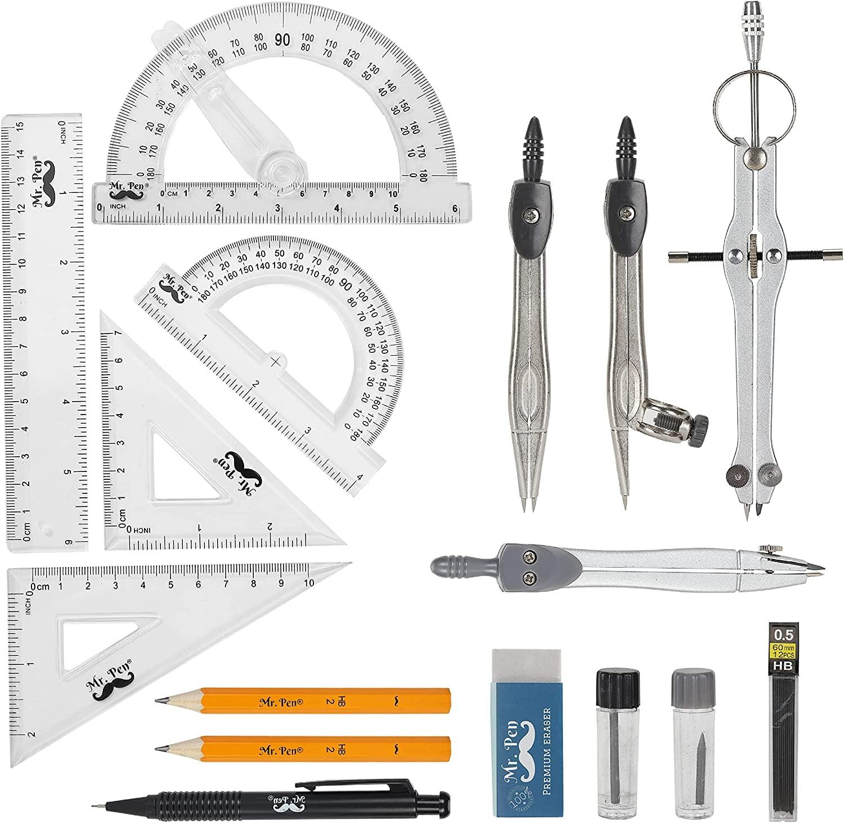
- Ruler / Straightedge: Drawing pentagonal edges, pyramid edges, and construction lines.
- Compass: Constructing regular pentagons and transferring equal lengths.
- Protractor: Measuring pentagonal angles and checking construction inclinations.
- Set Squares: Drawing perpendicular and parallel construction lines.
- Pencil: Drawing outlines, diagonals, and construction marks.
- Eraser: Removing unnecessary construction lines after completing the model.
- Cardboard or Construction Paper: Preparing the twelve pentagonal pyramid components for a physical model.
- Scissors and Adhesive: Cutting and joining the developed components when constructing a paper model.

Instrument-Based Construction Procedures

Method 1: Construction by Augmenting a Regular Dodecahedron
# Source: AI Source: Provided by: [Data Path: Persons Table -> ID Column: 1, Name_En Column: Motasem Essam] -> From: [ChatGPT] on [7/25/2026]
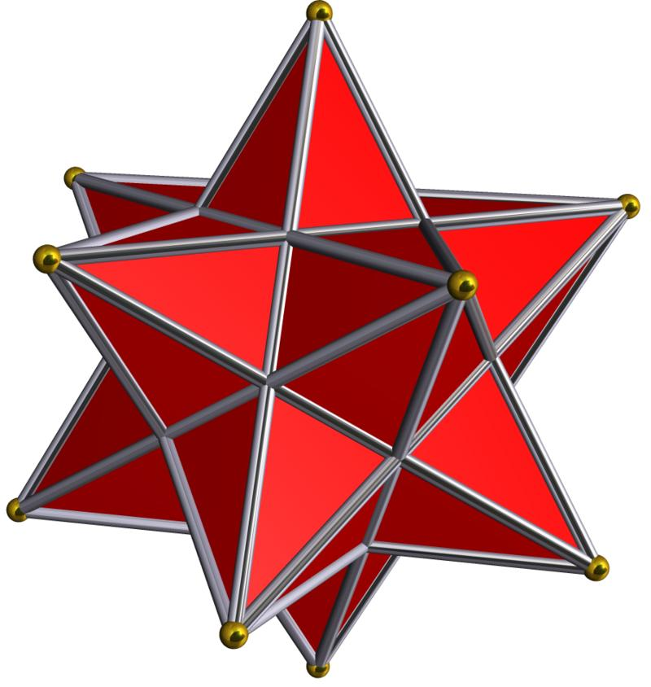
- Construct a regular dodecahedron with 12 congruent regular pentagonal faces.
- Identify the center of each pentagonal face using its diagonals.
- Draw a perpendicular construction line through each face center, extending outward from the dodecahedron.
- Determine the required height of each pentagonal pyramid.
- Mark the apex of each pyramid along its corresponding perpendicular line.
- Connect each apex to the five vertices of its pentagonal base.
- Repeat the procedure for all 12 pentagonal faces.
- Adjust the pyramid heights so that the five triangular side regions belonging to each pentagrammic face are coplanar.
- Remove or conceal the internal pentagonal base faces in the completed model.
- Darken the external pentagrammic boundaries and distinguish visible edges from hidden edges.

Method 2: Construction Using Pentagrammic Faces
# Source: AI Source: Provided by: [Data Path: Persons Table -> ID Column: 1, Name_En Column: Motasem Essam] -> From: [ChatGPT] on [7/25/2026]
- Draw a regular pentagram using a compass and straightedge.
- Construct the required pentagrammic face geometry.
- Repeat the construction to prepare twelve congruent pentagrammic faces.
- Arrange the faces according to the vertex arrangement of a regular dodecahedron.
- Connect the five pentagrammic faces that meet at each true vertex.
- Check that the adjoining edges correspond and that the faces form the correct stellated structure.
- Complete the remaining connections until all twelve faces are assembled.
- Verify the regularity and symmetry of the resulting polyhedron.

Method 3: Construction Using a Net and Paper Model
# Source: AI Source: Provided by: [Data Path: Persons Table -> ID Column: 1, Name_En Column: Motasem Essam] -> From: [ChatGPT] on [7/25/2026]
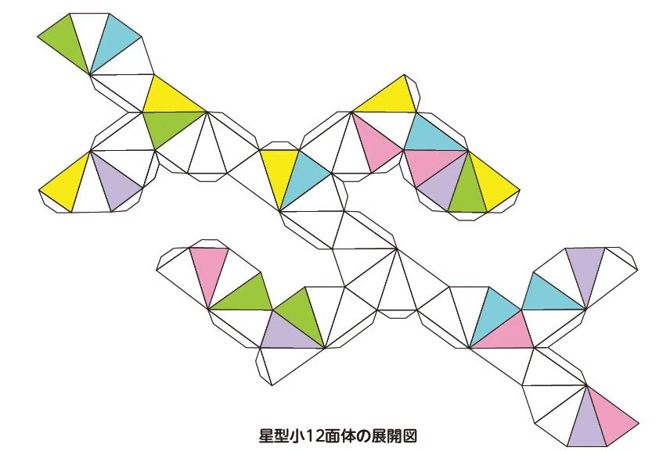
- Draw a regular dodecahedron net consisting of twelve connected regular pentagons.
- Construct a pentagonal pyramid net for each pentagonal face.
- Calculate and mark the five triangular side panels of each pyramid.
- Add attachment tabs where needed for paper assembly.
- Cut out the dodecahedron net and the twelve pyramid nets.
- Fold the pentagonal pyramid panels along their fold lines.
- Assemble the dodecahedron core.
- Attach one pentagonal pyramid to each of its twelve faces.
- Check the alignment of the pyramid edges and apex positions.
- Complete the model by joining the components and checking the stellated form.
The augmentation method is a recognized construction of the small stellated dodecahedron: twelve pentagonal pyramids are attached to a regular dodecahedron, with their heights adjusted to produce the coplanar triangular regions of its pentagrammic faces.

Relationship to Other Geometric Solids

Regular Dodecahedron
# Source: AI Source: Provided by: [Data Path: Persons Table -> ID Column: 1, Name_En Column: Motasem Essam] -> From: [ChatGPT] on [7/25/2026]
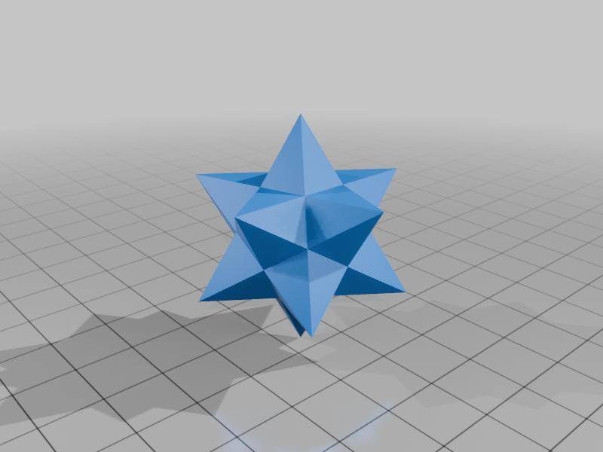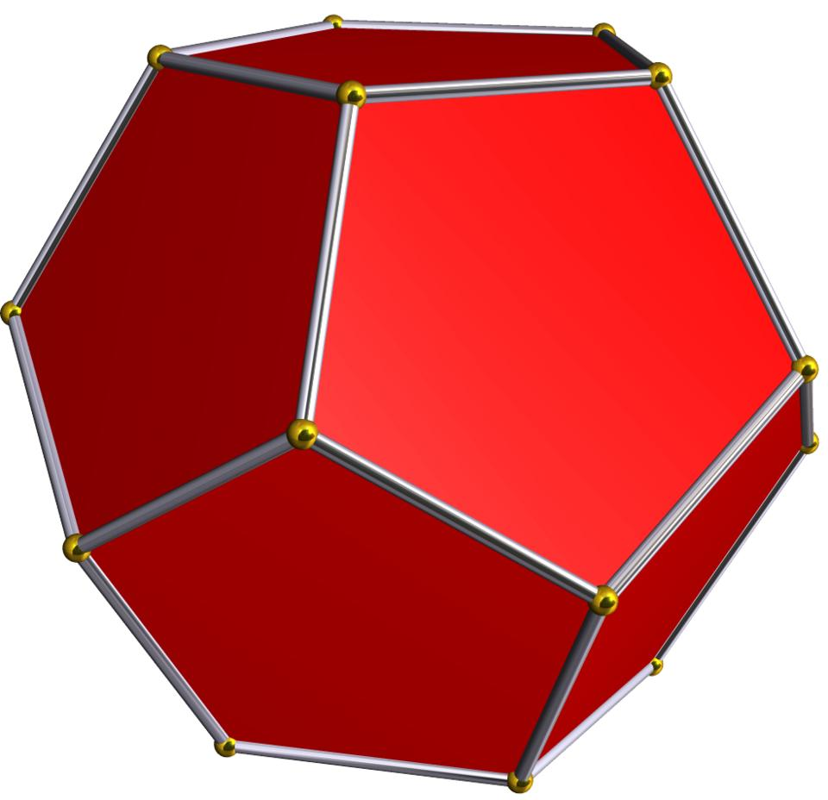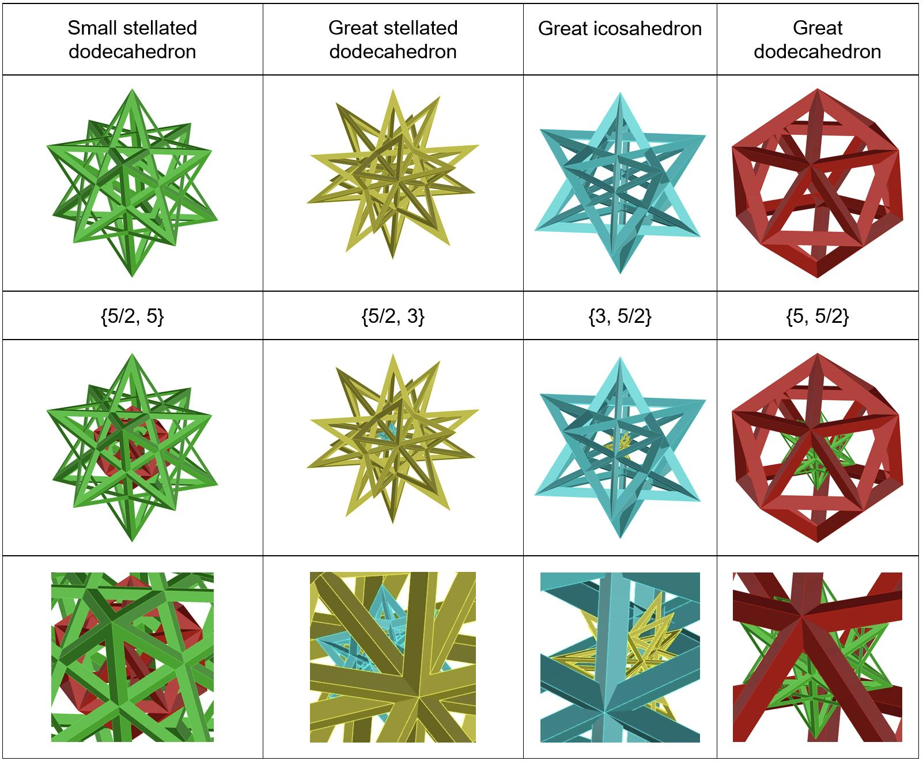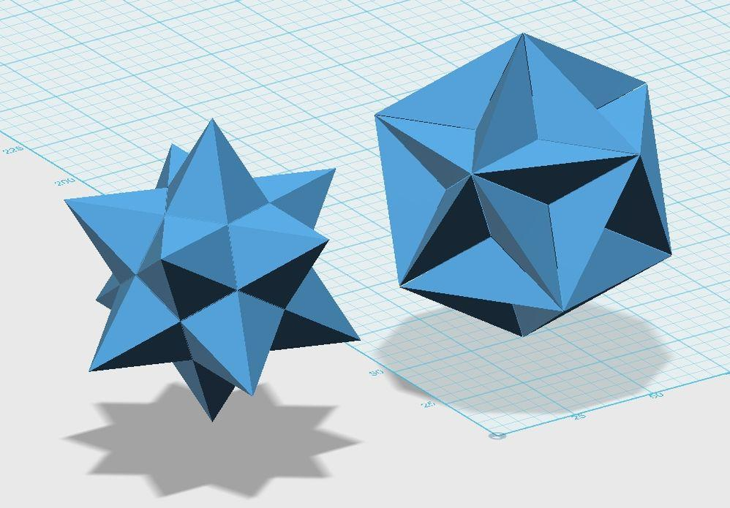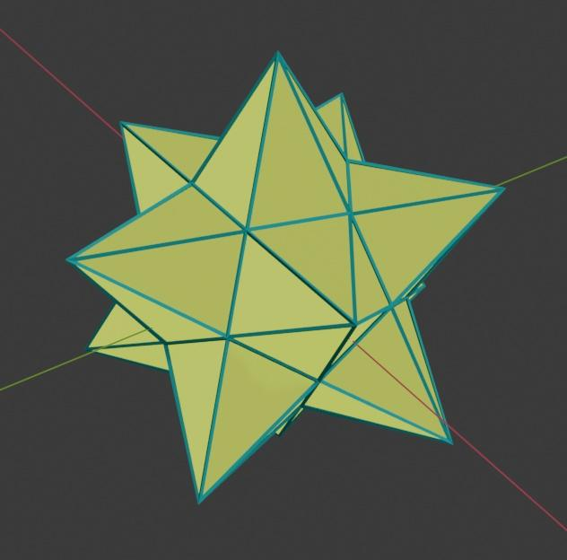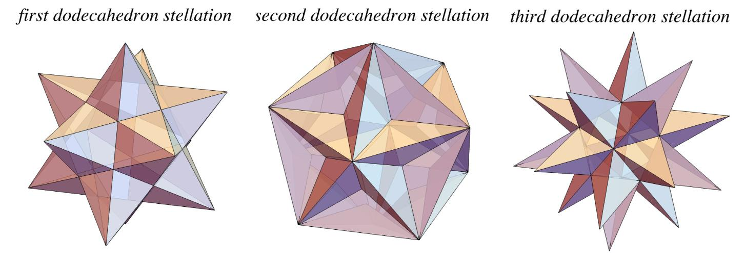
The Small Stellated Dodecahedron is obtained by stellating a regular dodecahedron.
- The original dodecahedron has 12 regular pentagonal faces.
- The stellated form has 12 pentagrammic faces.
- The original pentagonal face boundaries are extended to create outward-pointing star geometry.

Regular Icosahedron
# Source: AI Source: Provided by: [Data Path: Persons Table -> ID Column: 1, Name_En Column: Motasem Essam] -> From: [ChatGPT] on [7/25/2026]
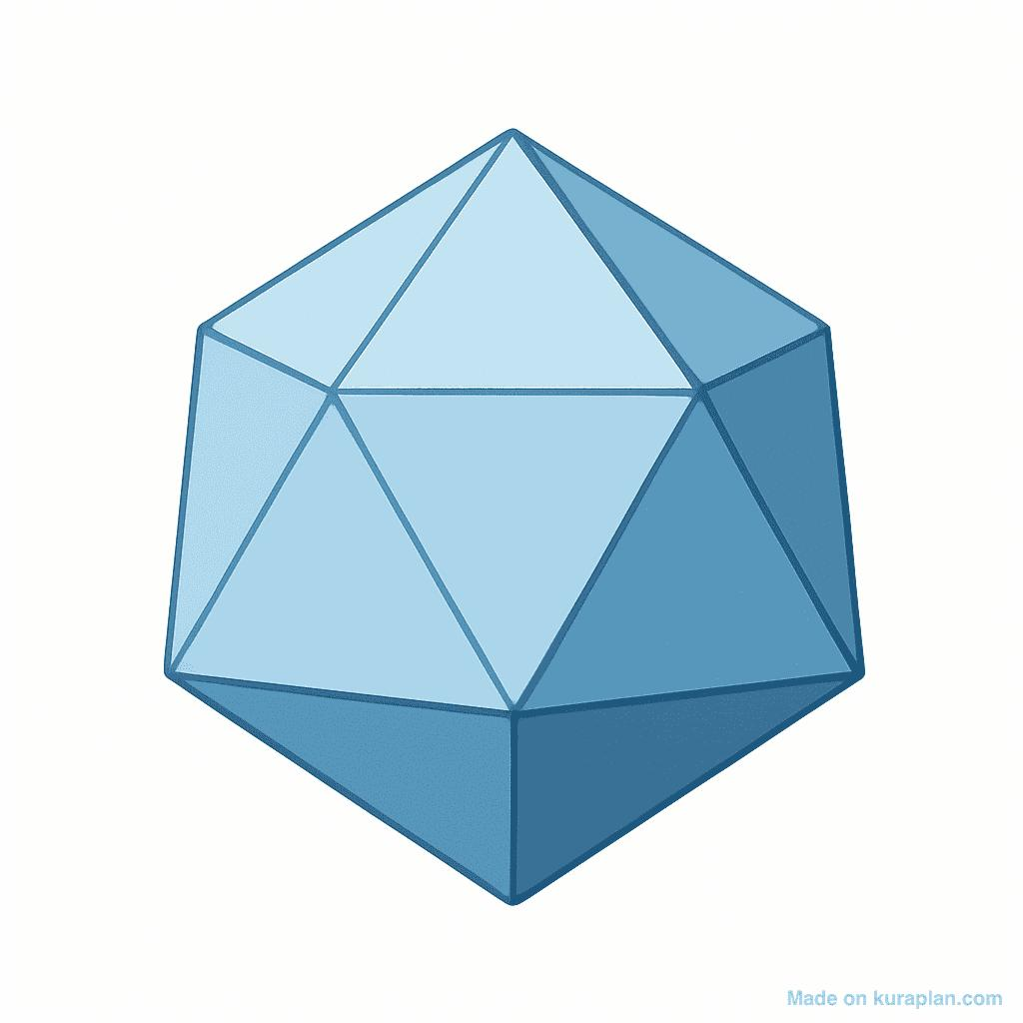
The convex hull of the Small Stellated Dodecahedron is a regular icosahedron.
Both solids share the same 12 vertex positions, but their edges and faces are arranged differently.

Great Dodecahedron
# Source: AI Source: Provided by: [Data Path: Persons Table -> ID Column: 1, Name_En Column: Motasem Essam] -> From: [ChatGPT] on [7/25/2026]
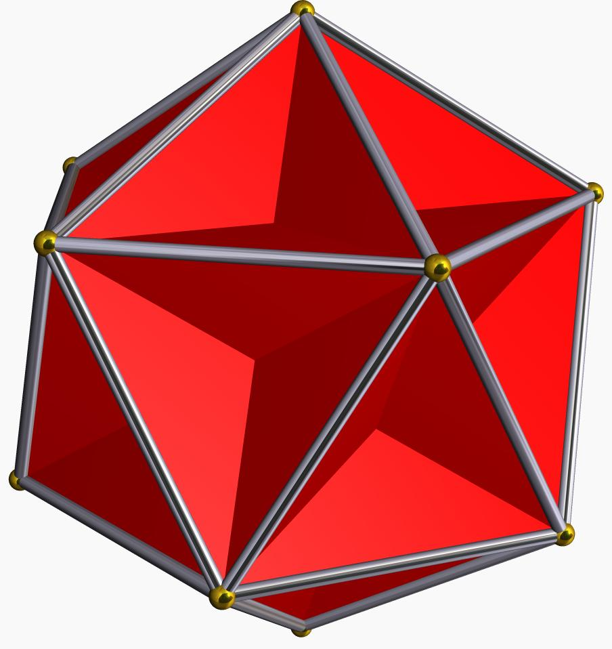
The Great Dodecahedron is the dual polyhedron of the Small Stellated Dodecahedron.
In this dual relationship:
- The 12 faces of the Small Stellated Dodecahedron correspond to the 12 vertices of the Great Dodecahedron.
- Its 12 vertices correspond to the 12 faces of the Great Dodecahedron.
- Their edge counts are both 30.

Comparison with Other Kepler–Poinsot Polyhedra
# Source: AI Source: Provided by: [Data Path: Persons Table -> ID Column: 1, Name_En Column: Motasem Essam] -> From: [ChatGPT] on [7/25/2026]
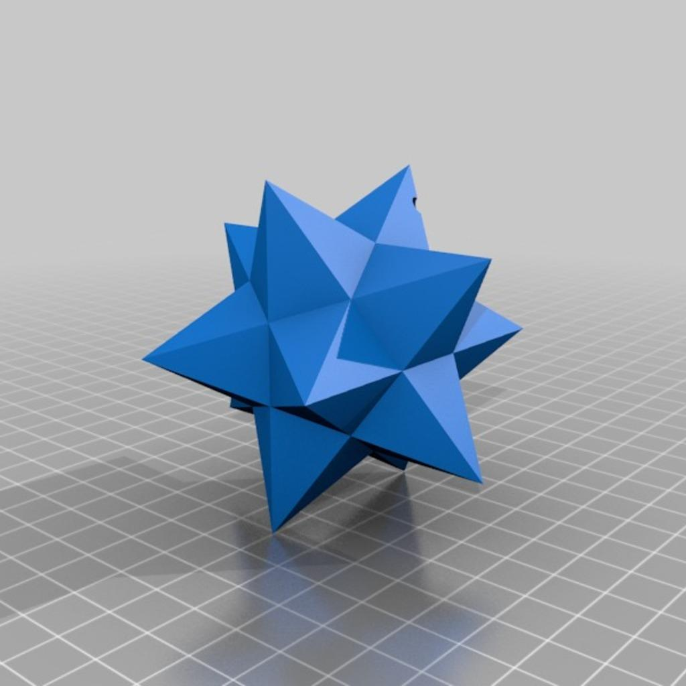
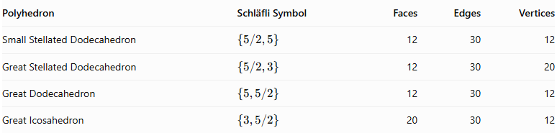
Polyhedron | Schläfli Symbol | Faces | Edges | Vertices
Small Stellated Dodecahedron | $$\{5/2,5\}$$ | 12 | 30 | 12
Great Stellated Dodecahedron | $$\{5/2,3\}$$ | 12 | 30 | 20
Great Dodecahedron | $$\{5,5/2\}$$ | 12 | 30 | 12
Great Icosahedron | $$\{3,5/2\}$$ | 20 | 30 | 12

Historical Background
# Source: AI Source: Provided by: [Data Path: Persons Table -> ID Column: 1, Name_En Column: Motasem Essam] -> From: [ChatGPT] on [7/25/2026]
- Paolo Uccello: A representation of the Small Stellated Dodecahedron appeared in a floor mosaic at St. Mark's Basilica in Venice, dating to approximately 1430.
- Johannes Kepler: Studied the solid and described it in Harmonices Mundi (1619).
- Louis Poinsot: Revisited the regular star polyhedra in 1809.
- Arthur Cayley: Gave the solid its established name, Small Stellated Dodecahedron.
- M. C. Escher: Used the solid as inspiration for artistic works, including Order and Chaos.

Main Classification
# Source: AI Source: Provided by: [Data Path: Persons Table -> ID Column: 1, Name_En Column: Motasem Essam] -> From: [ChatGPT] on [7/25/2026]
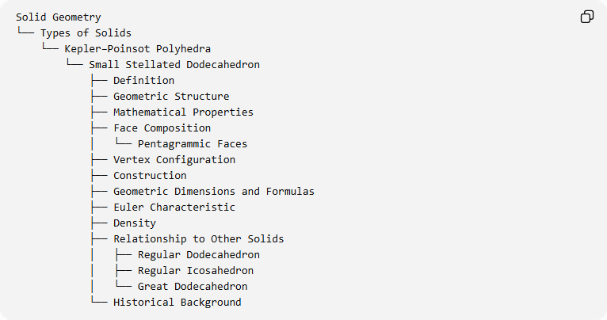
Solid Geometry
└── Types of Solids
└── Kepler–Poinsot Polyhedra
└── Small Stellated Dodecahedron
├── Definition
├── Geometric Structure
├── Mathematical Properties
├── Face Composition
│ └── Pentagrammic Faces
├── Vertex Configuration
├── Construction
├── Geometric Dimensions and Formulas
├── Euler Characteristic
├── Density
├── Relationship to Other Solids
│ ├── Regular Dodecahedron
│ ├── Regular Icosahedron
│ └── Great Dodecahedron
└── Historical Background

Key Points
# Source: AI Source: Provided by: [Data Path: Persons Table -> ID Column: 1, Name_En Column: Motasem Essam] -> From: [ChatGPT] on [7/25/2026]
- The Small Stellated Dodecahedron is one of the four Kepler–Poinsot polyhedra.
- It consists of 12 regular pentagrammic faces.
- Five pentagrams meet at each of its 12 vertices.
- Its Schläfli symbol is $\{5/2,5\}$.
- It has 30 edges, 12 faces, and 12 vertices.
- Its density is 3.
- Its dual is the Great Dodecahedron.
- Its convex hull is a regular icosahedron.
- It is a non-convex regular star polyhedron, not an irregular polyhedron.

Conclusion
# Source: AI Source: Provided by: [Data Path: Persons Table -> ID Column: 1, Name_En Column: Motasem Essam] -> From: [ChatGPT] on [7/25/2026]
The Small Stellated Dodecahedron is a fundamental example of a regular non-convex polyhedron. Its 12 pentagrammic faces, five-face vertex arrangement, high symmetry, and dual relationship with the Great Dodecahedron make it an important member of the Kepler–Poinsot family.
Further mathematical reference: Wolfram MathWorld – Small Stellated Dodecahedron.

